封面

262666266262

# 摘要

# 目錄

摘要 I

目錄 II

表目錄 III

圖目錄 IV

1. 前言 1

1.1 背景 1

1.2 研究目的 1

1.3 研究重要性與貢獻 4

2. 文獻探討 5

2.1 病人資料ssss 5

2.2 臨床資料庫 5

3. 研究方法 6

4. 結果 7

5. 討論與結論 8

參考文獻 9

# 表目錄

表格 2.1 5

表格 3.1 6

表格 3.2 6

# 圖目錄

*圖表* 4.1 7

*圖表* 4.2 7

# 前言

* 1. 背景

EMR(Al Ghamdi et al., 2021; Asokkumar & Soetikno, 2021; Barbazza et al., 2021; Bowman & Holzer, 2021; Camburu & Purcărea, 2020)

* 1. 研究目的
  2. 研究重要性與貢獻

# 文獻探討

1. 1. 病人資料ssss

表格 2.1

*測試表格*

|  |  |  |  |
| --- | --- | --- | --- |
|  |  |  |  |
|  |  |  |  |
|  |  |  |  |

* 1. 臨床資料庫

# 研究方法

表格 3.1

*測試表格*

|  |  |  |  |
| --- | --- | --- | --- |
|  |  |  |  |
|  |  |  |  |
|  |  |  |  |

表格 3.2

*測試表格*

|  |  |  |  |
| --- | --- | --- | --- |
|  |  |  |  |
|  |  |  |  |
|  |  |  |  |

# 結果

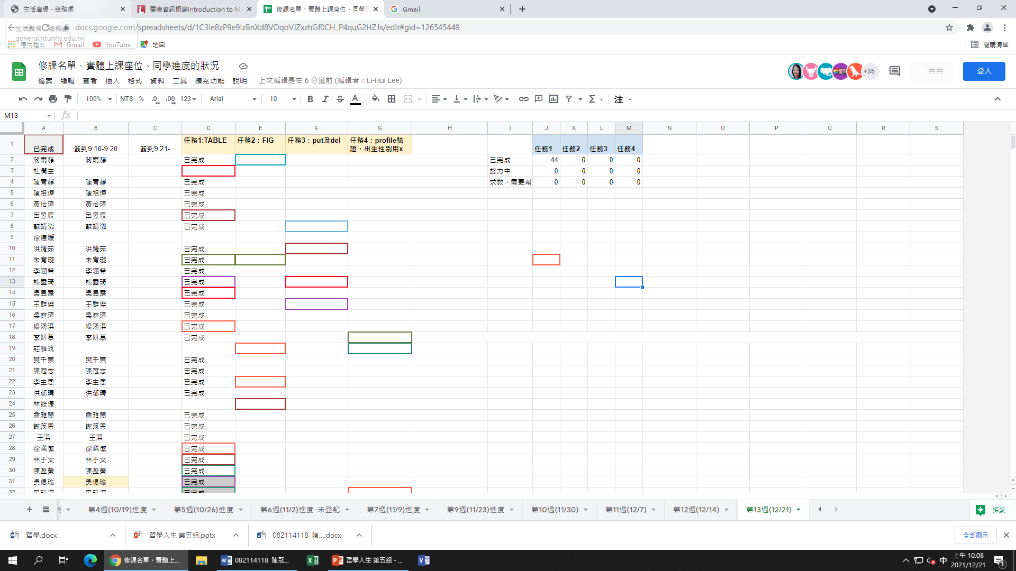

*圖表* 4.1

|  |
| --- |
|  |

*圖表* 4.2

# 討論與結論

如*圖表* 4.1所示表格 2.1

# 參考文獻

Al Ghamdi, S. S., Shwani, Z., & Ngamruengphong, S. (2021). Rubber band-assisted closure of a mucosal defect following duodenal emr. *VideoGIE*, *6*(11), 489-490. <https://doi.org/10.1016/j.vgie.2021.06.003>

Asokkumar, R., & Soetikno, R. (2021). Distal cap-assisted endoscopic mucosal resection (EMR-DC) For Non-lifting Colorectal Polyps - Are We Doing It Right? *Endoscopy*. <https://doi.org/10.1055/a-1655-5156>

Barbazza, E., Allin, S., Byrnes, M., Foebel, A. D., Khan, T., Sidhom, P., Klazinga, N. S., & Kringos, D. S. (2021). The current and potential uses of Electronic Medical Record (EMR) data for primary health care performance measurement in the Canadian context: a qualitative analysis. *BMC Health Serv Res*, *21*(1), 820. <https://doi.org/10.1186/s12913-021-06851-0>

Bowman, C. A., & Holzer, H. (2021). EMR Precharting Efficiency in Internal Medicine: A Scoping Review. *J Med Educ Curric Dev*, *8*, 23821205211032414. <https://doi.org/10.1177/23821205211032414>

Camburu, G., & Purcărea, V. L. (2020). EMR in Eye Units. *Rom J Ophthalmol*, *64*(1), 21-24. <https://www.ncbi.nlm.nih.gov/pmc/articles/PMC7141916/pdf/RomJOphthalmol-64-21.pdf>